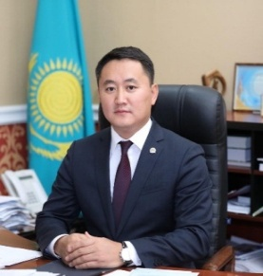
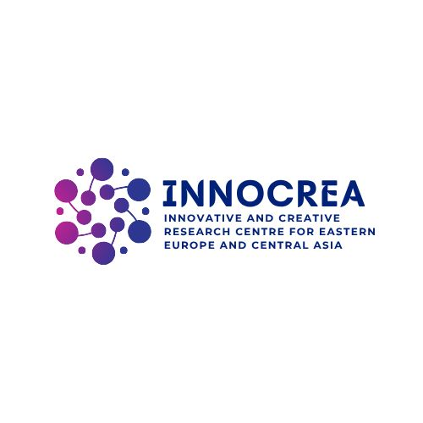
Full Name: TOLEGEN MUKHTAR ADILBEKULY
Date of Birth: July 16, 1980.
Place of Birth: Chulak-Kurgan village, Suzak District, Turkestan Region.
Nationality: Kazakh.
Academic Degree and Title: PhD in Philosophy, Candidate of Legal Sciences, Professor (recognized by the Committee for Quality Assurance in the Sphere of Education and Science, Ministry of Science and Higher Education of the Republic of Kazakhstan).

Awards
- Badge "Honored Worker of Education" – Ministry of Education and Science of the Republic of Kazakhstan, September 29, 2014. Certificate No. 438.
- Winner of the "Best University Teacher of 2014" award – Ministry of Education and Science of the Republic of Kazakhstan.
- Badge "75th Anniversary of Kostanay State Pedagogical Institute" – Rector K. Baimyrzaev, October 23, 2014.
- Jubilee medal "80th Anniversary of Al-Farabi Kazakh National University" – Rector G.M. Mutanov, June 28, 2016. Certificate No. 2414.
- Badge "Ybyrai Altynsarin" – Ministry of Education and Science of the Republic of Kazakhstan, September 25, 2017. Certificate No. 172.
- Jubilee medal "25th Anniversary of the Constitution of Kazakhstan", 2020. Certificate No. 8042.
- Badge "SHYGYS QAZAQSTAN KASIPODAQTARYNA-100 JYL", 2020.
- Jubilee medal "30th Anniversary of Independence of the Republic of Kazakhstan", December 2, 2021. Certificate No. 19123.
- Certificate of Appreciation from the Department of Defense Affairs of East Kazakhstan Region, May 7, 2022.
- Certificate of Appreciation from the President of the Republic of Kazakhstan Kassym-Jomart Tokayev, June 2022.
- Jubilee medal "30th Anniversary of the Judicial System of the Republic of Kazakhstan", June 21, 2022.
- Certificate of Appreciation from the President of the Republic of Kazakhstan Kassym-Jomart Tokayev, November 2022.
- Badge "For Active Service", Astana, December 26, 2022.
- Badge "30th Anniversary of the Law Enforcement Forces of the Republic of Kazakhstan", 2022.
- Badge "30th Anniversary of Kazakhstan Police", 2022.
- Badge "Excellent Service in Border Guard", 2022.
- Certificate of Appreciation from the Chief of the East Kazakhstan Regional Police Department, Major General E.B. Omarbekov, Ust-Kamenogorsk, 2023.
- Certificate of Appreciation from the Prosecutor of East Kazakhstan Region, Major General A.M. Bayshulakov, Ust-Kamenogorsk, 2023.
- Certificate of Appreciation from the President of the Republic of Kazakhstan Kassym-Jomart Tokayev, 2024.
- Certificate of Appreciation from the Director of the Republican Educational and Methodological Center for Continuing Education, Ministry of Enlightenment of the Republic of Kazakhstan, R. Sher, June 2024.
- Certificate of Appreciation from the Head of the AMANAT Party East Kazakhstan Regional Branch, S. Zhumadilova, Ust-Kamenogorsk, 2024.
- Certificate of Appreciation from the Head of the East Kazakhstan Department of the Anti-Corruption Agency of the Republic of Kazakhstan, D. Shakenov, 2024.
- Certificate of Appreciation from the Chief of the East Kazakhstan Regional Police Department, Major General E.B. Omarbekov, 2024.
Work Experience

30.12.2001 – 21.08.2003: First-category translator, legal specialist of HR department, executive secretary of the admissions committee, lecturer at the Department of Criminal and Civil Law – North Kazakhstan Law Institute of KazGUU (Pavlodar).
27.08.2003 – 17.09.2008: Assistant to the Rector, lecturer, specialist in the research department, Dean of the Faculty – Almaty Law Academy of KazGUU; Head of Legal Studies Department – College of Law and Economics of Almaty Law Academy of KazGUU (Almaty).
06.2007 – 08.2007: Chairperson of Electoral Precinct No.169 of the Bostandyk District, Almaty.
01.08.2008 – 17.09.2008: Assistant to the President (Rector) – Kazakh Humanitarian Law University (Almaty).
22.09.2008 – 26.01.2012: Advisor to the Rector, Deputy Dean, Associate Professor – Al-Farabi Kazakh National University (Almaty).
26.01.2012 – 23.05.2016: Vice-Rector for Academic and Methodological Affairs – Kostanay State Pedagogical Institute (Kostanay).
24.05.2016 – 29.01.2018: Vice-Rector for Innovation and Strategic Development – Zhetysu State University named after I. Zhansugurov (Taldykorgan).
29.01.2018 – present: Rector of Sarsen Amanzholov East Kazakhstan University (Ust-Kamenogorsk).

Education: higher
№ | Full name of the educational institution, faculty (department) | Admission Year | Graduation Year | Specialty, qualification  Specify the number of the diploma or certificate
 | Kazakh State Law Academy | 1997 | 2001 |  | Law №0020401  Diploma with honors
 | Sarsen Amanzholov East Kazakhstan University | 2020 | 2022 |  | Pedagogy and Psychology  №00017510015

Languages: Fluent in Kazakh and Russian, English – intermediate level
Public and Political Activity: Deputy of the VII and VIII convocations of the Ust-Kamenogorsk City Maslikhat; Chairman of the Party Control Commission of the East Kazakhstan Regional Branch of the "AMANAT" Party

