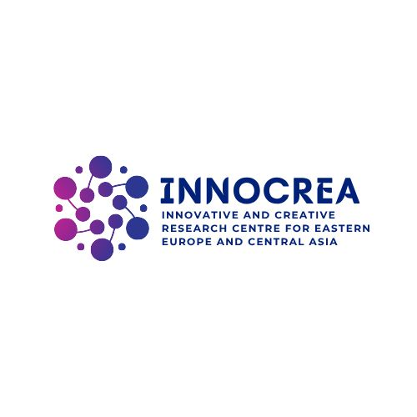  INNOCREA member | 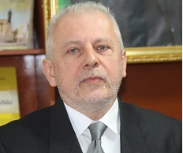

Family Name | FIGUS
Name | Alessandro
Institution | CREATECH ACADEMY
Position | Director Intrenational Department
Mother Language | Italian
English (A1, A2, B1, B2, C1, C2) | C1

EDUCATION – WORK EXPERIENCE
Graduate: Political Sciences at University of Genova, Italy Post graduate: Political Sciences, at University of Nice, Sophia Antipolis, France; Honoris Causa: Management, Moldova; Chair: International Relations, Diplomatic Sciences and European Union Law and Organisation. He is Italian Journalist and expert of International Relations, Science PO and Eastern Europe. The last studies and research are about Immigration, Geopolitical, Social Security and Freedom. Today is Vice Rector for the International Relations and European Integration at International Institute of Management, IMI-Nova (Moldova). Till 30 June 2020 was Professor at North Kazakhstan State University where was Vice Rector of International relations professor at Link Campus University where since 2007, has taught the course of European Political Organisation European Political Systems, and since 2016 Diplomatic Sciences and European Union law. He is coordinator of more than 30 EU and International projects as well in Azerbaijan, Russia, Moldova, Ukraine and Kazakhstan since 2006. He is NPD co-director of Midas SPS Project in Moldova (Control of team of mini-UAVs to support counter-terrorism missions) and member of SPS Nato project Witness (Wide InTegration of sensor Networks to Enable Smart Surveillance). He is full member of International Political Science Association (IPSA) and Italian SISE, editor in chief of several scientific journal with Scopus, etc. He is author of 24 Monography and more than one hundred scientific articles, Adviser for Internationalisation of the Rector, University of Cassino and Southern Lazio (Italy) from a.y. 2018/2019, Chair of History of International Relations and History of Oriental Europe (6 Ects), since a-y 2020/21; Chair of International Sport Management and Sport Governance, 4 ECTS from a.y. 22/23; since 2005 Vice Rector for International Affairs and European Integration at International Institute of Management, IMI-Nova, Co-Director Double Diploma in Management with University of Nice (F) and IMI-Nova Chişinău (since 2008, Republic of Moldova), from a.y. 1999-2000; Adviser of NATO-SPS at North Kazakhstan State University TEAM, Consultant, since 2019.

Relevant PUBLICATIONS
1. Bologna Process and Fisheries education, edited by, with T. Potempa, Eurlink, Rome, 2019.
2. Tuning environmental competencies in Russian fishery education for sustainable development, with Thomas Potempa and Sergey Shibaev, ISBN 978-88-97931-744, Eurilink, Roma, 2016.
3. Quality Control, with L.A.Ismagilova, E.V. Orlova and T.Torre, Tacis Jep JEP 27107-2006, Ufa University Press, ISBN 978-5-4221-0058-3, Ufa, Russian Federation, 2010.
4. Sustainable “University – Enterprise” partnership, LUDES University Press, CD Book, ISBN 978-88-6047-029-9, Lugano, Switzerland, 2009
5. Bologna process in Geopolitical Social Security and Freedom Journal, Sciendo, Poland, Issue 2-2018.
6.The problem of harmonizing the environmental priorities of electricity generating companies and regional socio-economic systems: Dea-Based approach, (SCOPUS, Q3), with Iosifov, V.V., Almastyan, N.A., Chepurko, Y.A., Hiển, N.H., Krotova, M.A., on “International Journal of Energy Economics and Policy”, Volume 7, Issue 5, 2017, Pages 159-165.
7. Measuring Regional Inequalities by amenity productivity approach for sustainable economic and environmental policies in EU, (SCOPUS, Q3), edited with Dimitrious Giannias, Yuri Chepurko, Nguyễn Hoàng Hiển, JEL Classifications: Q5; Q50; R11; R58; Q56, on “International Journal of Energy Economics and Policy” 7 (4), 107-114, 2017.
8. Brexit: historical and socio-political developments, by Alessandro Figus and Alessandro Rossetti, on “Academic Journal of Interdisciplinary Studies”, Classification Q2, Vol. 8 issue 4, Richtmann Publishing, p. 27, 2019, Italy.
9. Kazakhstan: socio-economic development, research and innovation, by Alessandro Figus and Dinmukhammed Shaikin, on “Academic Journal of Interdisciplinary Studies”, Classification Scopus Q2, Vol- 8. Issue 4, Richtmann Publishing, p. 113, 2019, Italy.
10. Social evolution in times of Covid 19, between politics, economics and health in Strategic Management, International Journal of strategic management and decision support system in strategic management, ISSN 2334-6191, vol. 26, 1-2021.
11. Determining factors of sports dropout of young scholars: a cross-sectional analysis in the 8-13 year age group. with A Pisaniello, A Figus, S Digennaro, D Spulber - Frontiers in Sports and Active Living (Classification Scopus Q2), vol. 6, 2024.
12. Double relationship between risk management and CSR in the Italian Healthcare sector: the case of the Lombard “Health Protection Agencies” (ATS) with Patrizia Gazzola and Stefano Amelio, WOFRIN, Springer, 2019.
13.Information society and digital leadership in the globalised educational system: Political approach, in www.europeanproceedings.com, e-ISSN: 2357-1330 , DOI: 10.15405/epsbs.2021.07.02.3, pp 18-24, 2020
14. The importance of Developing Skills and Teachers Training for Leadership, with Diana Spulber in “The importance of developing skills and teachers training for leadership” (edited by Betta, Figus, Olkova, Spulber), Kozybayev University press, ISBN 9786013226620, pp.5-12, May 2023.
15.Determinanti e motivazioni della partecipazione e dell'abbandono alle attività sportive in Italia, with Pisaniello A. in Atti del convegno (edited by Peluso Cassese F.), REN – Research Educational Neuroscience 2023, Edizioni universitarie romane, 2023.
16. The competence Leadership, from philosophy and political direction and the challenger in education with Diana Spulber, on Geopolitical, Social Security and Freedom Journal 5 (2), GSSFJ, Sciendo Edit. Vol. 5, issue 2, 2022.

INTERNATIONAL PROJECTS EXPERIENCE
- Contact person for University of Genova in Join European Project Tempus Meda JEP 32128-2004, University of Damascus, Syrie, 2005-2008;
- Grantholder of EU Tempus Tacis project Structural Measures n° T065A06 Bologna promoters, Moldova, 2006-2007, contractor Link Campus University of Malta;
- Tempus Tacis, Environmental Management project, Alicante, Spain, 2006;
- Grantholder Tempus Tacis SCM T079B06 Qualification, Moldova, 2007-2008;Contact person for LCUM Tempus Tacis JEP 27122-2006, Fergana, Uzbekistan, 2007-2009;
- Contact person for LCUM Tempus Tacis SCM T059B06 Bologna process, Russia, 2007-2008;
- Contact person for LCUM Tempus Tacis JEP 27107-2006,
- Project TEMPUS CTAE JPHES544517 coordinated by University of Genova (with Ukr, Ru). 2014-2017;
- Erasmus + project Tunasia (Vietnam and Thailand) LCU coordinator, 2017/2020;
- Director MIDAS project, Moldova, NATO, 2017/2019 and Witness Project NATO, 2017/2019, Moldova;
- ERASMUS KA107 (IMI-NOVA Moldova) with Insubria Uni (Italy), Genova Uni (Italy), ROMATRE (Italy), SAN Poland.
- Coordinator Erasmus+ DESTT www.destt.com
- Erasmus+ VET TECGREMED www.tecgremed.com
- Erasmus- Ka 171 with IT Astana University and Sarsen Amanzholov University, coordinator 2024-2027.
- LESLIE Erasmus+ Ka2 key 1 with Uzbekistan and Kazakhstan, 2024/2025 contact person UNICAS.

